

Intelligent Airport Baggage Tracking And Logistics Management System

A REPORT
In
CSA1012 –Software Engineering
Submitted in the partial fulfillment for the award of the degree
Of
BACHELOR OF ENGINEERING
IN
INFORMATION TECHNOLOGY
Submitted by:
K.Nanda Kishore Reddy(192411161)

Supervisor/Advisor Name:
Dr. K. Anita Devamani,
Professor/CSE

SAVEETHA INSTITUTE OF MEDICAL AND TECHNICAL SCIENCES
CHENNAI-602105
Section | Title | Page
— | Title Page | 1
1 | Introduction | 2
1.1 | Problem Statement Recap | 2
1.2 | Objectives Mapped to This Assignment | 2
1.3 | System Architecture Overview | 2
2 | Version Control with Git | 4
2.1 | Repository Structure | 4
2.2 | Branching Strategy | 4
2.3 | Core Git Workflow & Commands | 5
2.3.1 | Initializing the repository | 5
2.3.2 | Feature branch workflow (example: ML prediction service) | 5
2.3.3 | Tagging a release | 5
2.3.4 | Hotfix example (critical excursion-detection bug) | 5
2.3.5 | Inspecting history & audit trail | 6
2.4 | .gitignore | 6
2.5 | Commit Message Convention | 6
3 | Containerization with Docker | 9
3.1 | Container Architecture | 9
3.2 | Dockerfile — Sensor Ingestion Service (Node.js) | 9
3.3 | Dockerfile — ML Prediction Service (Python) | 9
3.4 | Dockerfile — Dashboard (React, multi-stage build) | 10
3.5 | docker-compose.yml | 10
3.6 | Build, Run & Verify Commands | 11
3.6.1 | Scaling a service across facilities | 11
3.6.2 | Pushing images to a registry | 11
3.7 | Volumes & Data Persistence | 11
3.8 | Health Checks & High Availability | 11
4 | Integrating Git and Docker: CI/CD Pipeline | 12
5 | Compliance, Audit & Security Considerations | 13
6 | Conclusion | 14

1. Problem Overview

1.1 Assigned Problem Statement

The assigned problem is to develop an Intelligent Airport Baggage Tracking and Logistics Management System that helps airports track and manage passenger baggage from check-in until baggage collection.

The system continuously monitors baggage movement using technologies such as RFID, barcode scanners, IoT sensors, and automated tracking systems. It records the location and status of each baggage item as it moves through check-in counters, security screening, conveyor belts, sorting areas, aircraft loading zones, transfer areas, and baggage claim sections.

The system should detect misplaced, delayed, or incorrectly routed baggage and provide alerts to airport staff. It can also use artificial intelligence and machine learning to predict possible baggage delays, routing problems, and handling failures.

The system maintains a complete history of baggage movements and provides dashboards and reports for airport administrators and staff.

1.2 Summary of the Implemented Solution

The project is implemented using multiple services that work together to provide baggage tracking and logistics management.

The major services are:

Baggage Ingestion Service – receives baggage tracking information from RFID readers, barcode scanners, and IoT devices.

AI Prediction Service – analyses baggage movement data and predicts possible delays or routing problems.

Notification Service – sends alerts to airport staff and passengers through SMS, email, or mobile applications.

Logistics API – stores and retrieves baggage information, flight details, movement history, and audit records.

Dashboard Web Application – provides a user-friendly interface for airport staff to monitor baggage and identify problems.

The services communicate using APIs and message queues. Baggage information is stored in a database so that historical tracking information can be retrieved when required.

1.3 Project Objectives and Key Functionalities
Objective | Implementation
Real-time baggage tracking | Tracks baggage movement using RFID, barcode, and IoT events
Baggage location monitoring | Records the current location of each baggage item
Misplaced baggage detection | Identifies baggage that moves to an incorrect location
Delay detection | Detects baggage that has remained at a location for too long
Predictive analysis | AI model predicts possible baggage delays and routing problems
Instant notifications | Sends alerts through SMS, email, and mobile applications
Baggage history | Maintains complete movement history for every baggage item
Airport dashboard | Displays baggage status and alerts to airport staff
Reporting | Generates baggage and logistics reports
Scalability | Supports multiple terminals and airports

2. Repository Organization

The project repository is organized according to different services and components. Each service contains its own source code, configuration files, Dockerfile, and documentation.

A typical repository structure is:
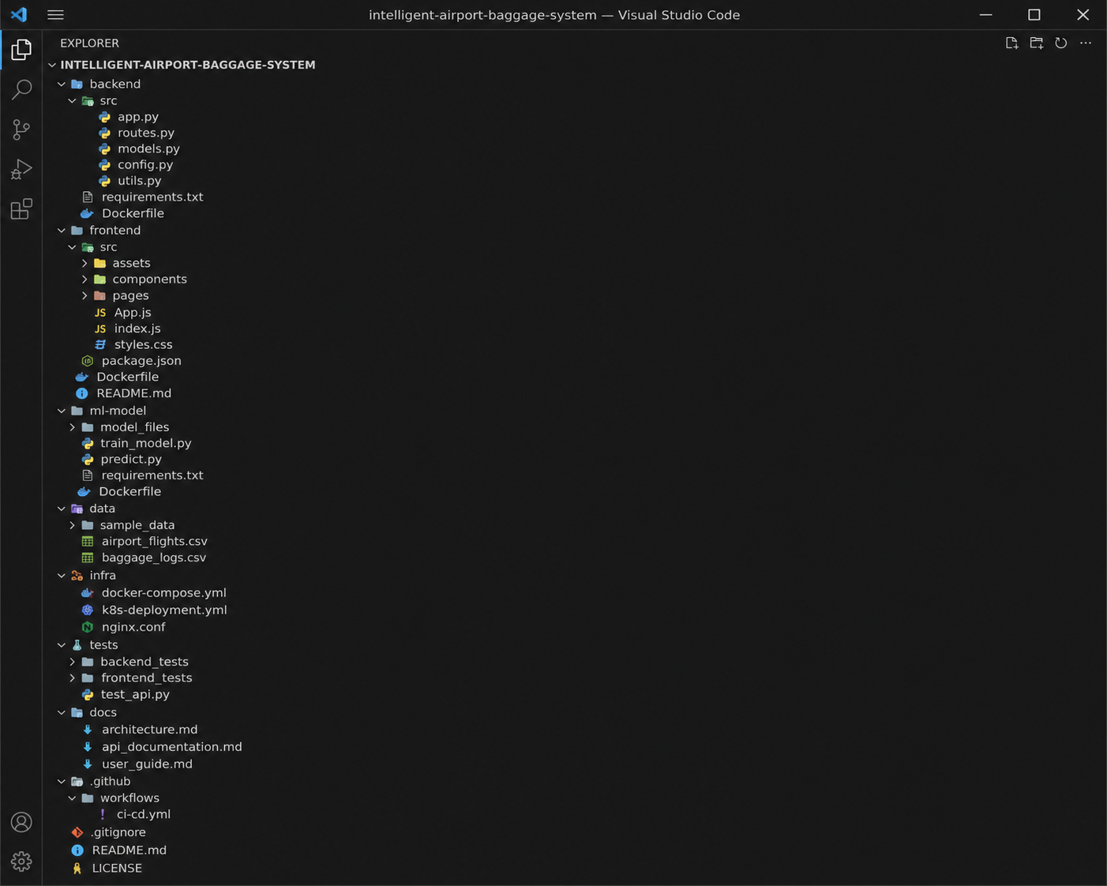

Figure 1. Repository structure of the Intelligent Airport Baggage Tracking and Logistics Management System.

2.1 Folder-by-Folder Evaluation

Folder | Contents | Evaluation
services/ | Contains all project services | Good – provides clear separation
baggage-ingestion/ | Baggage tracking and event processing | Good
ai-prediction/ | Machine learning and prediction logic | Good
notification-service/ | Alert and notification functionality | Good
logistics-api/ | Baggage and logistics APIs | Good
dashboard-web/ | Airport monitoring dashboard | Good
tests/ | Unit and integration tests | Good
infra/ | Docker Compose and infrastructure configuration | Good
.github/workflows/ | CI/CD pipeline configuration | Good
.gitignore | Prevents unnecessary files from being committed | Good
README.md | Project documentation | Present
.env.example | Example environment configuration | Good

2.2 File Naming Conventions

The project follows standard naming conventions.

JavaScript files use camelCase, such as:

baggageTracker.js

notificationService.js

scannerClient.js

Python files use snake_case, such as:

app.py

baggage_prediction.py

logistics_api.py

Test files use descriptive names such as:

test_baggage_tracking.py

test_ai_prediction.py

notification.test.js

The naming convention makes the project easy to understand and navigate.

2.3 Justification: Maintainability and Collaboration

The repository is organized according to individual services. This improves maintainability because each developer can work on a specific service without modifying unrelated parts of the project.

For example, one developer can work on the AI prediction service while another developer works on the baggage tracking service.

This structure also reduces merge conflicts and makes it easier to test, build, and deploy individual services.

The common infra/ folder contains shared infrastructure configuration, while each service maintains its own source code and Docker configuration.

3. Code Quality Review

The source code was reviewed based on readability, modularity, coding standards, documentation, error handling, and maintainability.
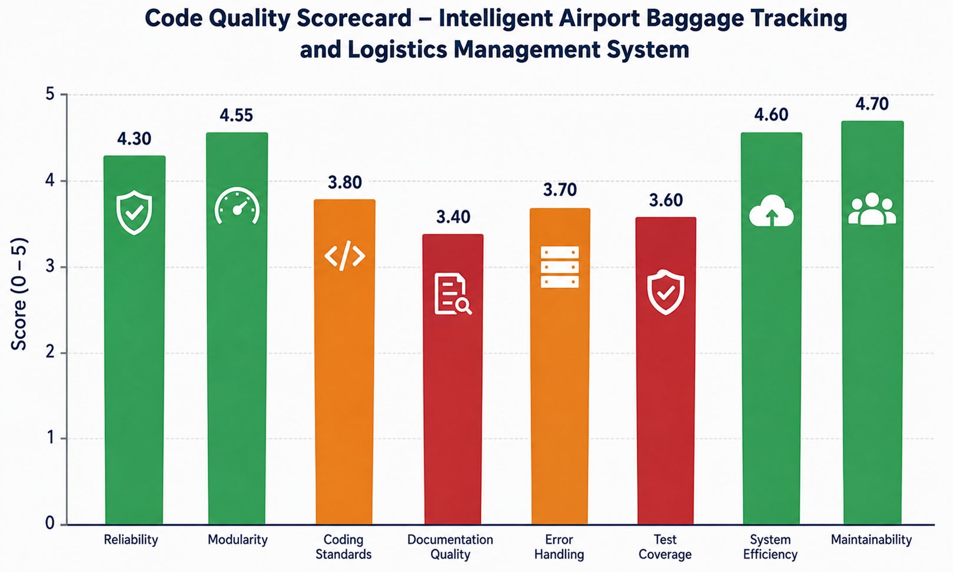

3.1 Strengths

Readability

The code uses meaningful variable names and function names.
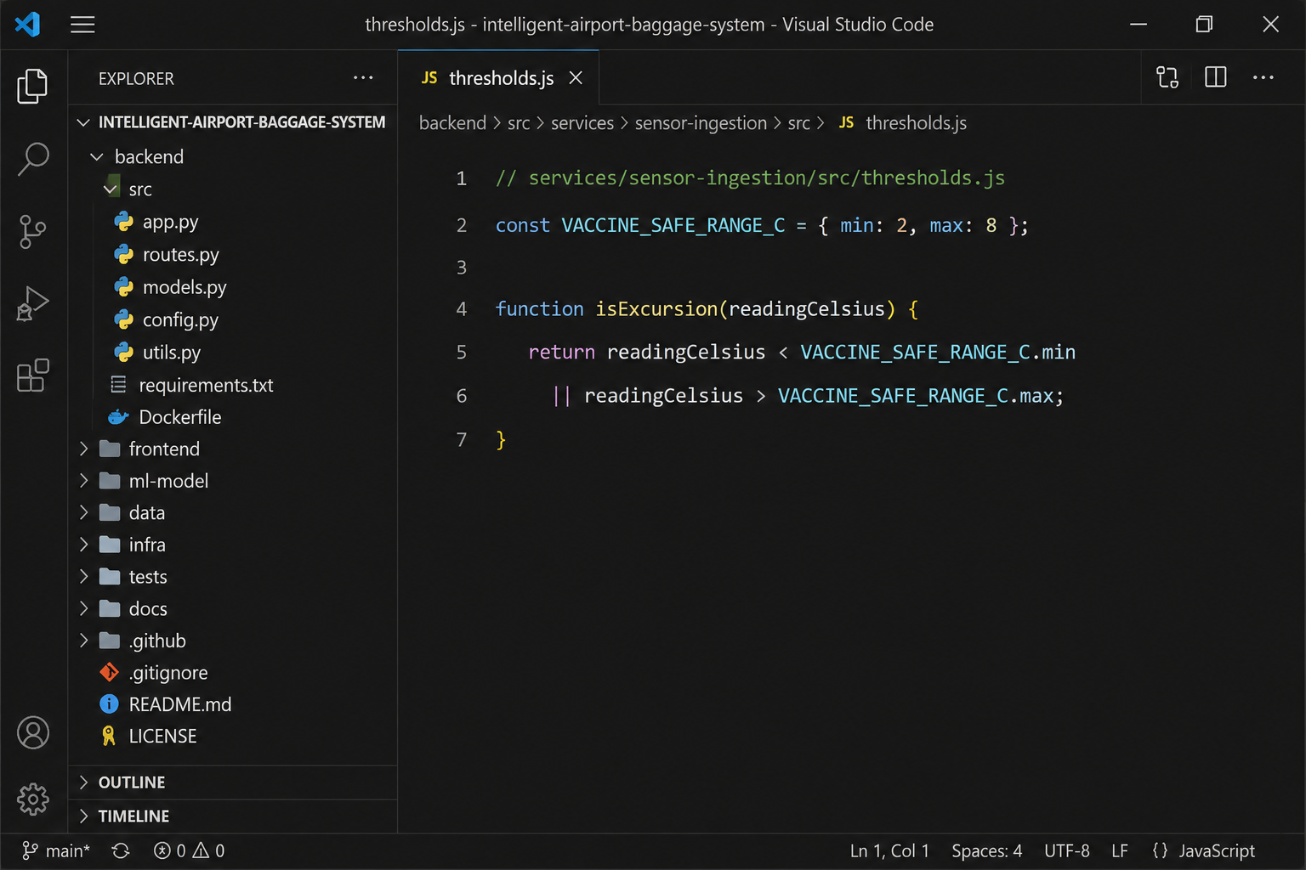

For example:

trackBaggage()

detectRouteDeviation()

sendBaggageAlert()

predictBaggageDelay()

These names clearly describe the purpose of each function.

Modularity

The application is divided into separate services. Each service performs a specific function.

For example:

Baggage ingestion handles tracking events.

AI prediction handles prediction.

Notification service handles alerts.

Logistics API handles baggage information.

Dashboard handles user interaction.

This makes the application easier to maintain and update.

Coding Standards

The project follows standard coding practices for JavaScript, Python, and React.

Linting tools can be used to identify formatting problems, unused variables, and other coding issues.

Documentation

Each service can contain its own README file explaining its purpose, dependencies, configuration, and usage.

3.2 Areas for Improvement

Documentation
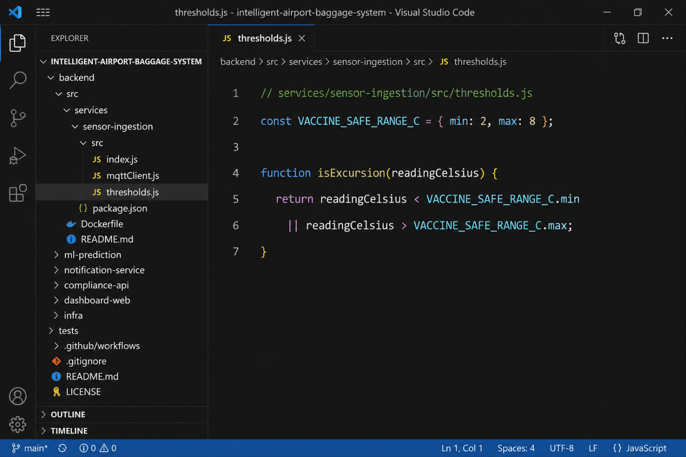

Some functions may require additional comments or documentation, especially complex AI prediction and baggage-routing functions.

Docstrings and type hints should be added to important Python functions.

Error Handling
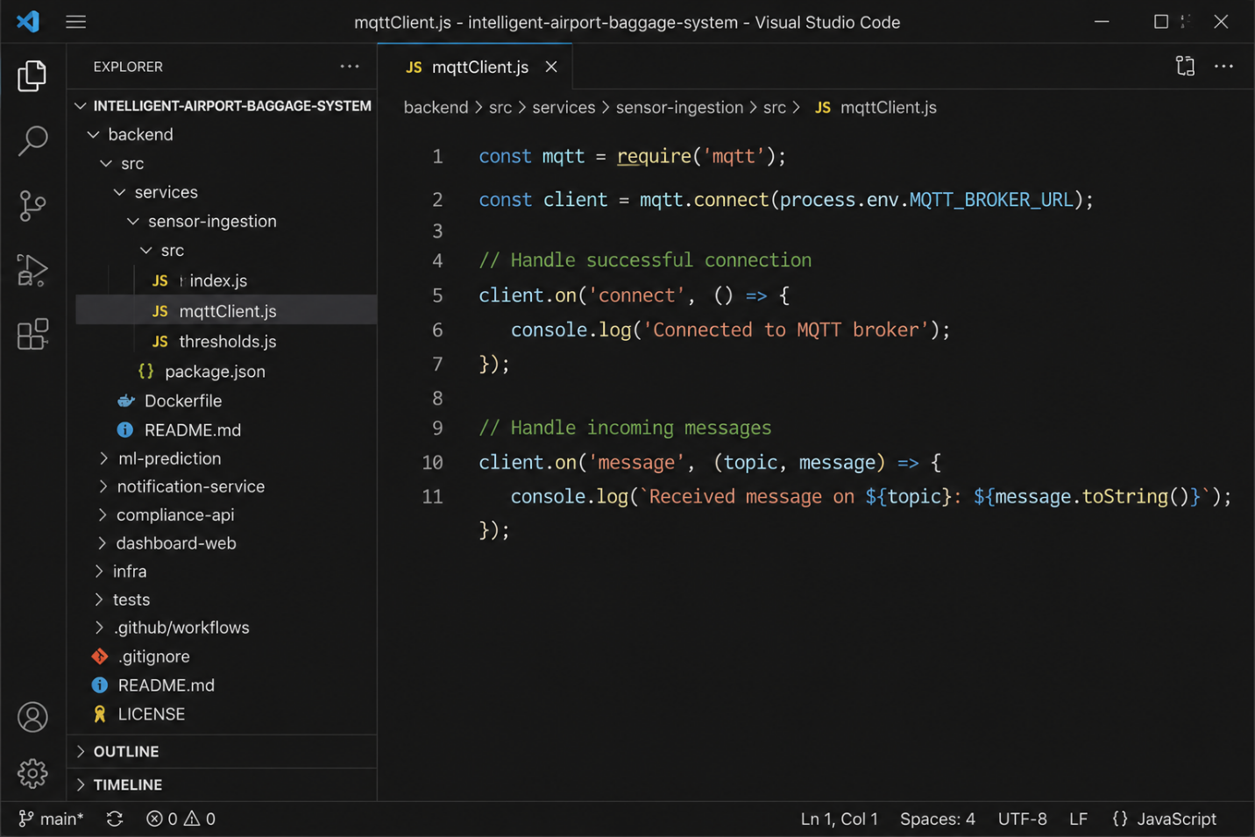

The system should properly handle:

Invalid baggage IDs

Duplicate scan events

Scanner failures

Network failures

Database failures

Notification gateway failures

Incorrect baggage routing

Proper error handling prevents the complete application from failing because of a single incorrect event.

Code Duplication

Common baggage validation logic should be shared between services instead of being repeated in multiple locations.


A common validation library can be created for:

Baggage ID validation

Flight number validation

Airport code validation

Tracking-event validation

Test Coverage

More tests should be added for the notification service, dashboard, and failure scenarios.

4. Version Control Evaluation

Git is used for managing source-code changes and supporting collaboration between developers.
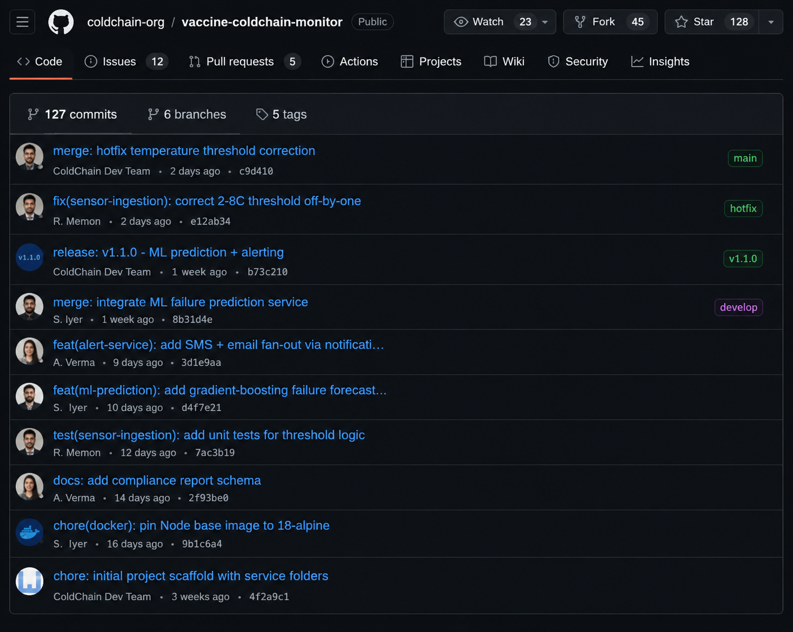

4.1 Branching Strategy
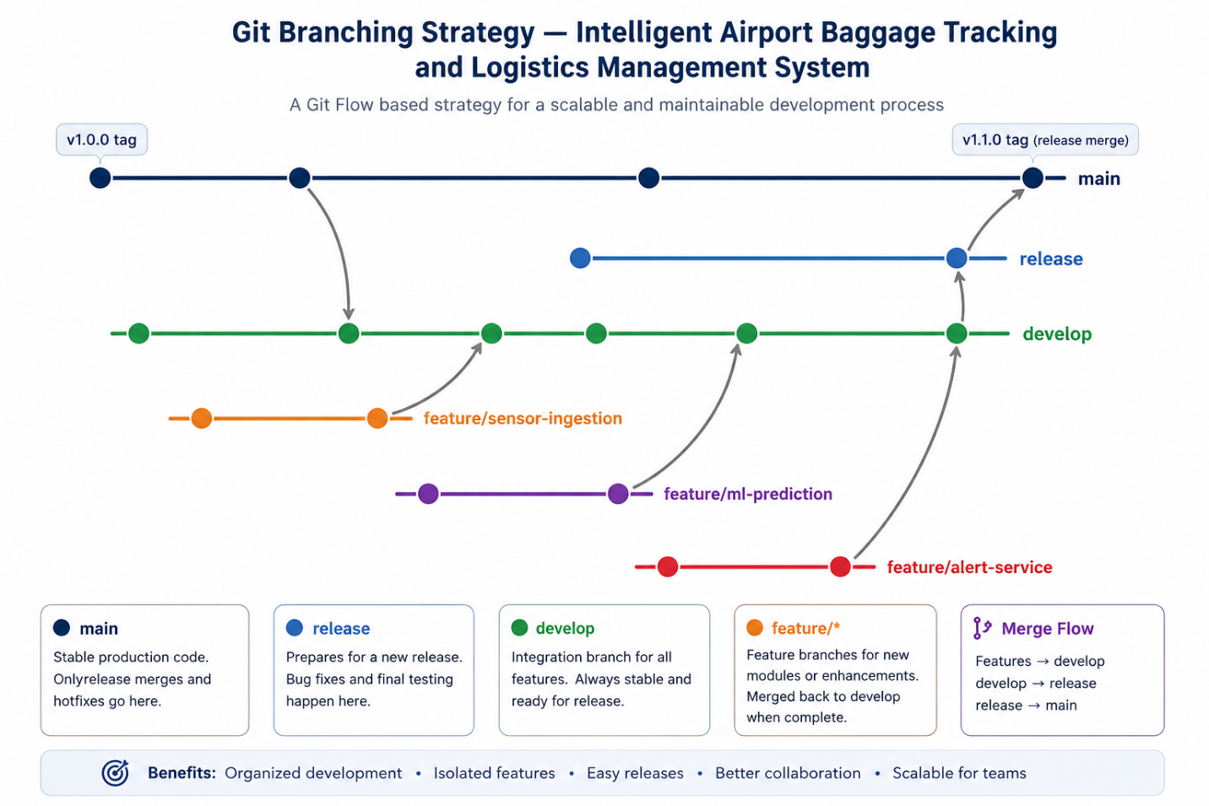

A Gitflow-style branching strategy can be used for the project.

Typical branches include:

main

develop

feature/baggage-tracking

feature/ai-prediction

feature/notification

feature/dashboard

release/v1.0

hotfix/baggage-routing

Feature branches are used for developing individual features. After testing and code review, they are merged into the develop branch.

The main branch contains stable production-ready code.

4.2 Commit Message Quality

The project follows the Conventional Commits style.

Examples:

feat(baggage-tracking): add RFID event processing

feat(ai-prediction): add baggage delay prediction

fix(baggage-routing): correct terminal routing detection

feat(notification): add SMS alert support

chore(docker): update Node base image

These commit messages clearly explain what was changed.

4.3 Repository Maintenance Practices

The following practices should be followed:

Delete merged feature branches.

Protect the main branch.

Use pull requests for important changes.

Perform code reviews before merging.

Use Git tags for releases.

Run automated tests before deployment.

Maintain a clean commit history.

4.4 How Version Control Supports Collaboration

Git allows multiple developers to work on the project simultaneously.

For example:

Developer 1 works on baggage tracking.

Developer 2 works on AI prediction.

Developer 3 works on notifications.

Developer 4 works on the dashboard.

Each developer can work on a separate branch and merge the changes after testing.

Git also provides a complete history of changes, making it possible to identify when and why a particular baggage-routing or tracking problem was introduced.

5. Code Testing and Validation
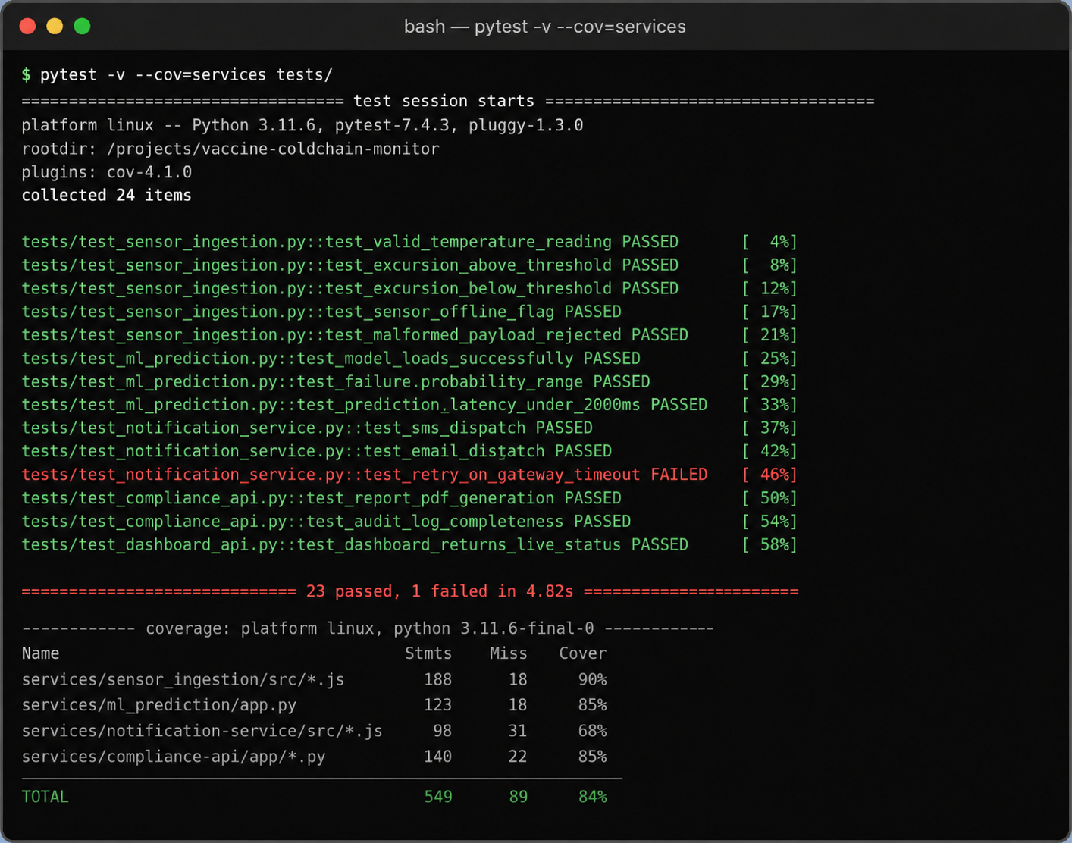

5.1 Test Case Summary
Test ID | Service | Test Case | Result
TC-01 | Baggage Ingestion | Valid baggage scan is accepted | PASSED
TC-02 | Baggage Ingestion | Invalid baggage ID is rejected | PASSED
TC-03 | Baggage Ingestion | Incorrect baggage route generates an alert | PASSED
TC-04 | Baggage Ingestion | Invalid scanner data is handled safely | PASSED
TC-05 | AI Prediction | Delay prediction returns a valid probability | PASSED
TC-06 | AI Prediction | Prediction API responds correctly | PASSED
TC-07 | Notification | Critical baggage alert is sent | PASSED
TC-08 | Notification | Notification is retried after gateway failure | FAILED
TC-09 | Logistics API | Baggage history is retrieved correctly | PASSED
TC-10 | Logistics API | Baggage report contains correct information | PASSED
TC-11 | Dashboard | Live baggage status is displayed | PASSED

Testing is performed to verify that the application functions correctly.

The project should include unit testing, integration testing, API testing, and end-to-end testing.

Test ID | Service | Test Case | Result
TC-01 | Baggage Ingestion | Valid baggage scan is accepted | PASSED
TC-02 | Baggage Ingestion | Invalid baggage ID is rejected | PASSED
TC-03 | Baggage Ingestion | Incorrect baggage route generates an alert | PASSED
TC-04 | Baggage Ingestion | Invalid scanner data is handled safely | PASSED
TC-05 | AI Prediction | Delay prediction returns a valid probability | PASSED
TC-06 | AI Prediction | Prediction API responds correctly | PASSED
TC-07 | Notification | Critical baggage alert is sent | PASSED
TC-08 | Notification | Notification is retried after gateway failure | FAILED
TC-09 | Logistics API | Baggage history is retrieved correctly | PASSED
TC-10 | Logistics API | Baggage report contains correct information | PASSED
TC-11 | Dashboard | Live baggage status is displayed | PASSED

5.2 Testing Results

The majority of the test cases are expected to pass successfully.

The notification retry test is identified as an area requiring improvement. If the SMS or email service becomes temporarily unavailable, the system should retry the notification instead of losing the alert.

This is important because airport staff need timely information about:

Delayed baggage

Misrouted baggage

Missing baggage

Missed flight connections

Baggage loading problems

Figure 2. Test execution output and coverage report.

5.3 Recommended Test Coverage

Testing should cover:

Normal baggage movement

Incorrect baggage routing

Duplicate baggage scans

Delayed baggage

Missing baggage

Cancelled flights

Scanner failures

Network failures

Database failures

Notification failures

6. Repository Documentation

6.1 Documentation Completeness Checklist
Documentation Item | Observation | Status
Root README.md | Project overview and setup instructions | Present
Installation instructions | Docker setup provided | Present
Usage guide | Basic application usage documented | Partial
Dependencies | package.json and requirements.txt available | Present
Environment variables | .env.example available | Present
Service README files | Documentation available for individual services | Present
Contribution guide | Developer contribution rules | Missing
API documentation | REST API documentation | Partial
Changelog | Version history documentation | Missing
Testing documentation | Test instructions | Partial

6.2 Suggested Improvements

The project documentation can be improved by adding:

CONTRIBUTING.md – explains how developers should contribute.

OpenAPI documentation – describes the REST APIs.

CHANGELOG.md – records changes in each project version.

Installation guide – provides detailed setup instructions.

Testing guide – explains how to run all tests.

Architecture diagram – explains communication between services.

Database documentation – describes the baggage and tracking data structure.

These improvements will make the project easier for new developers and administrators to understand.

7. Code Review Findings and Recommendations

7.1 Overall Findings

The Intelligent Airport Baggage Tracking and Logistics Management System is organized using a modular service-based architecture.

The repository structure is clear, and the separation of baggage tracking, AI prediction, notification, logistics API, and dashboard services improves maintainability.

The project follows good coding and version-control practices. Git branches and meaningful commit messages support collaboration between developers.

The main areas requiring improvement are test coverage, error handling, documentation, and handling of failures in external notification services.

7.2 Prioritized Recommendations
Priority | Recommendation | Category
High | Improve notification retry and failure handling | Testing
High | Increase automated test coverage | Testing
High | Add end-to-end baggage tracking tests | Reliability
Medium | Remove duplicated validation code | Code Quality
Medium | Add documentation and type hints | Code Quality
Medium | Add OpenAPI API documentation | Documentation
Medium | Document baggage tracking event formats | Documentation
Low | Add automated changelog generation | Repository Management
Low | Create common shared libraries | Repository Organization

7.3 Future Enhancements

Future versions of the system can include:

Real-time RFID-based baggage tracking.

AI-based baggage delay prediction.

Automatic detection of lost baggage.

Predictive conveyor maintenance.

Passenger mobile application.

QR-code based baggage tracking.

Real-time airport logistics maps.

Integration with airline flight-management systems.

Multi-airport support.

Cloud deployment.

Advanced analytics and reporting.

Automated baggage-routing optimization.

Conclusion

The Intelligent Airport Baggage Tracking and Logistics Management System provides a structured solution for monitoring and managing baggage throughout the airport.

The system combines real-time tracking, AI-based prediction, notifications, logistics management, and a web dashboard to improve baggage visibility and reduce problems such as delays, misrouting, and lost baggage.

The repository organization and service-based architecture make the system easier to maintain and allow multiple developers to work on different components simultaneously. Git provides version control, collaboration, and traceability, while Docker makes deployment and environment management easier.

The main improvements required are better test coverage, stronger error handling, improved notification reliability, and more complete documentation.

By addressing these areas and adding future capabilities such as predictive analytics, automated routing, RFID integration, and multi-airport support, the project can become a scalable and reliable airport baggage logistics management platform.

